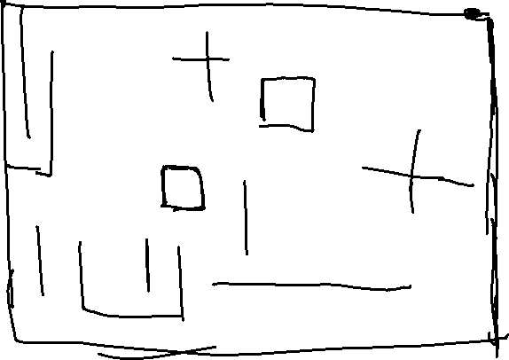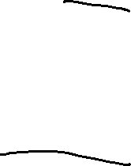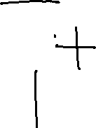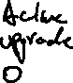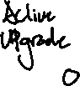

For this project, I am planning on working together with Raymond. We are planning on making a game that has support for both 2-player and single-player. The idea is there will be two tanks in a maze-like map (we are planning to make it randomly generate a new terrain for every game but that might be too ambitious), in 2-player mode, the tanks will be separately controlled by each person and in single player mode, one tank will be controlled by the player and the other by an AI. For the AI, the plan is to have different difficulties.

As before mentioned, the terrain will be in a maze. The players cannot go over the walls. Each player (with no powerups) can shoot 2 bullets per 3 seconds. The bullets can ricochet off the walls, but you cannot kill your own tank. There will be powerups that will randomly spawn in somewhere random on the map. Once the player collides with it, it will grant the player a certain upgrade. Powerups will not be stackable, once you pick up a powerup, any powerup you had before that will be replaced.

Before every game, there will be a menu that asks the player(s) for a integer value ( > 0). The objective is simple, you try to kill the other tank will not dying yourself. If you successfully kill the other tank, you gain a point. Once a player has been killed, a new match starts in a new map. All games will be the first player that reaches the value that they entered before wins. If two players die at the same time, no points will be given to either player, and a new match will be started.

For the powerups, we are planning to make the following:

* Shotgun (allows the user to shoot multiple bullets at once in a spray. Planning on making the ability last 7 seconds. The bullets will all still ricochet)
* Laser (a continuous beam that kills the other player in a certain number of ticks when they are in contact. Lasts for 7 seconds.)
* Shield (makes the player temporarily invulnerable to normal attacks)
* Ray cannon (lasts for one shot, a straight beam of laser that will penetrate walls and shields and one-shot the other player)
* Homing Missel (lasts for one shot, allows the player to shoot a bullet that will track and follow the other player for a certain amount of time. Maybe something like 10 seconds)

Controls:

For single-player:

The player can use either WASD or the arrow keys to move. They do not need to select which one they want to use beforehand (both controls will work in game). Can either use V or / to shoot.

2-player:

Player1 will use WASD to move and V to shoot.

Player2 will use the arrow keys to move and / to shoot.

The tanks are only able to move forward and backward (W for forward, S for backward [same concept for the arrow keys]) but they are able to turn left or right from A or D and their respective controls. Unlike a real-life tank, the headpiece will not move separately from the body. When the tank turns, it will simply change the direction its entire body is facing.

Press escape at anytime to pause the game and bring up the pause menu, from there you can resume the game, go to main menu, or start a new game with current settings.

We are also planning on adding console controller compatibility. This idea is still a work in progress, and we are not sure if we will implement it yet.